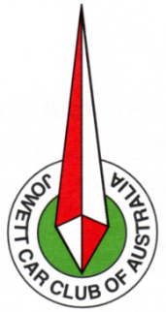
THE JOWETT CAR CLUB OF AUSTRALIA INC.
1906
ASSOCIATIONS INCORPORATION REGISTERED No. A9664E
APPLICATION FOR MEMBERSHIP

I, ………………………………………………………………………………………………..
(Full name of Applicant)

of ……………………………………………………………………………………………………

………………………………………………………………… Post Code: ……………….
(Address of Applicant)

desire to become a member of the Association called the JOWETT CAR CLUB of AUSTRALIA Inc. In the event of my admission as a member, I agree to be bound by the rules of the Association.

Name you wish on name Badge: ……………………………………………………………………..

Spouse/Partner’s name: …………………………………………….

Phone: …………………………….. Mobile: ……………………………….

Email: …………………………………………… Occupation: ………………………………………

Joining Fee: $20.00 Full Membership $55.00 pa

Associate Membership $25.00 pa Family membership – per additional member $15.00 pa

(family membership is only available for Partners & children under 16 years )

…………………………………………Date: …… / ….. / 20 ………
(Signature of Applicant)

I, ……………………………………………. A member of the Association nominate the applicant, who is known by me, for membership of the Association.

……………………………………………… Date: …… / ….. / 20 ………
(Signature of Proposer)

I, ……………………………………………. A member of the Association second the applicant, who is known by me, for membership of the Association.

……………………………………………… Date: …… / ….. / 20 ………
(Signature of Seconder)

How did you hear of us? ……………………………………………….
AS PER THE RULES OF JCCA INCORPORATED

VEHICLE DETAILS:

Jowett Model: ………………………. Chassis No: …………………… Engine No: ……………………

Body No: …………………………. Body Colour: ……………. Trim Colour: …………………

Registered: Yes No Registration No. ..…………………...

Please post completed form and remittance to the Secretary
23 Barnetts Road Winston Hills NSW 2153

